1. Introduction

* HTML
* CSS
* JS
* The DOM

HTML and CSS are static, JS is dynamic and programmatically responsive.

* The DOM
* How to update and style page content.
* The hidden world of browser events and how to hook into and respond to them.
* JS event loop allows better, more performance code.

Const name = ‘Miguel’;

Var name = ‘Miguel’;

1. The DOM

The DOM defines a standard for accessing everything in HTML in the form of a tree.

The DOM is the full parsed interpretation of the HTML markup.

<https://www.w3.org/standards/techs/dom#w3c_all>

The DOM is not part of the JavaScript language.

The DOM is constructed from the browser and globally accessible by JavaScript code using the document object.

1. Selecting Page Elements With CSS Selectors

In CSS, you need to use the # at the beginning of the selector to target an element by its ID. In CSS, you need to use the . (the period!) at the beginning of the selector to target elements by their class. In CSS, you target specific elements by their tag name.

1. Select Page Element By ID

document.getElementById();

This is correct because it's .getElementById() has the word "Id", not "ID" and because it expects the string "logo", not "#logo".

document.getElementById('strawberry-banner')

1. Select Page Elements By Class Or Tag

document.getElementsByClassName('brand-color');

document.getElementsByTagName('p');

document.getElementsByTagName('article');

document.getElementsByClassName('fancy-footer');

returns an HTML collection

1. Nodes, Elements, and Interfaces...Oh My!

Node = Class, node = object.

<https://developer.mozilla.org/en-US/docs/Web/API/Node>

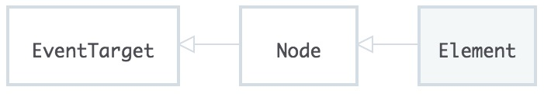

<https://developer.mozilla.org/en-US/docs/Web/API>

1. More Ways To Access Elements

<https://api.jquery.com/>

document.querySelector('#fanciful-butterfly');

document.querySelector('p.callout');

document.querySelectorAll('.articles p');

1. Lesson summary

Yay!